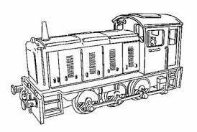Heritage Shunters Trust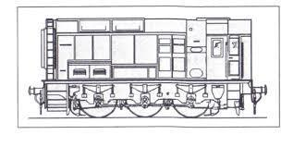
Membership Application Form

Heritage Shunters Trust is the trading name of The South Yorkshire Railway Company Limited
A Member of the Heritage Railway Association
Company Registration no: 02342203 | Charity Commission Registration no: 702394

I / We wish to become a member of The South Yorkshire Railway Co Ltd – Heritage Shunters Trust and undertake to comply with its rules and regulations.
Name: ………………………………………………………………………………Date of Birth (Junior only) ……………………………………
Address: ………………………………………………………………………………………………………………………………………………………………...
Postcode: ……………………………………. Mobile: ………………………………………………………………………………………………………….
Landline: ………………………………………………. E-mail address: …………………………………………………………………………………….
Membership Fees:
Life / Corporate: £250 | Adult: £15 | Senior: £10 | Family / Overseas: £20 | Junior: £8
We can claim 25% of your fees / donations if you are a Taxpayer and are willing to Gift Aid: Please Advise if you are willing to Gift Aid: Yes / No. If in the future you no longer are a taxpayer, please let us know. Thank you.
Data Protection Act:
The information you provide on this form is for The South Yorkshire Railway Co Ltd – Heritage Shunters Trust purposes ONLY and will NOT be passed to any other organisation.

You can pay your membership either by Bank Transfer or by sending a cheque, please see the following:
By Bank Transfer:
Bank Account Name: The South Yorkshire Railway Co Ltd
Sort Code: 30-97-51
Bank Account: 04641013
Please send an email to advise your payment including your details to: shunter.membership@gmail.com
By cheque:
Please make the cheque payable to: The South Yorkshire Railway Co Ltd
Send your payment plus your contact details and membership number to Membership Secretary:
Mr Alan Wilson,
37 Hillside Road
Stratford on Avon
Warwickshire
CV37 9EB
07983 117638

